Georgia Chapter February Bulletin

Upcoming Events

Thursday, February 8th, 7:00 PM ET: Monthly Mentoring
The Monthly Mentoring Sessions are held every 2nd Thursday of the month and are open to all Georgia Chapter Clubs and Members.
This is your opportunity to get your questions answered. No agenda, you control the discussion.

Register For Mentoring Here: REGISTER HERE

Saturday, February 10th, 12:00 PM ET: ACME Model Investment Club
The ACME club meets on the 2nd Saturday of the month at noon. All are welcome to come and learn about investing with us.

Join The Meeting Here: https://global.gotomeeting.com/join/594493789

Saturday, February 17th, 12:00 PM ET: Central Georgia Model Investment Club (CGMIC) Meeting
CGMIC meets monthly on the 3rd Saturday at noon. Meetings are free and open to the public.

Join The Meeting Here: https://global.gotomeeting.com/join/735717165

Keep Up With All The Latest Georgia Chapter Events Here

Monthly Mentoring Series
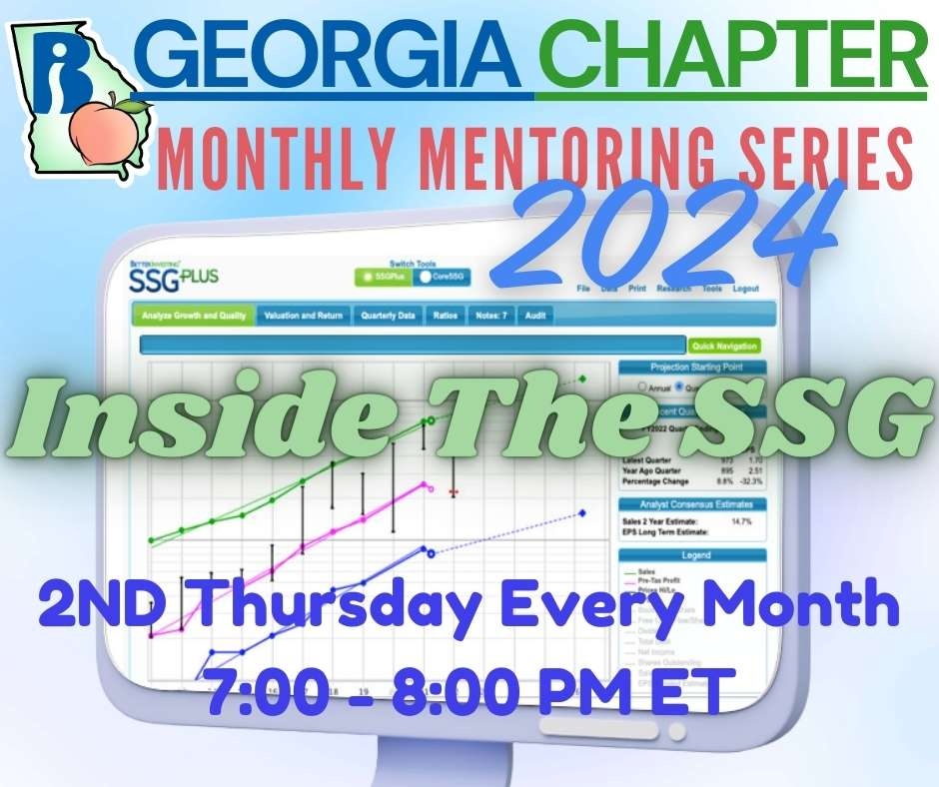
Monthly Mentoring 2024 resumes Thursday, February 8th at 7:00 PM ET. Join us as Director Howard Johnson takes us on a tour through SSG. It’s a jungle out there, so let Howard be your guide.
Join us on the 2nd Thursday at 7:00 PM ET for an in-depth look into different aspects of the SSG. Have questions? Get them answered here!
REGISTER HERE to be an SSG insider.
Portfolio Contest
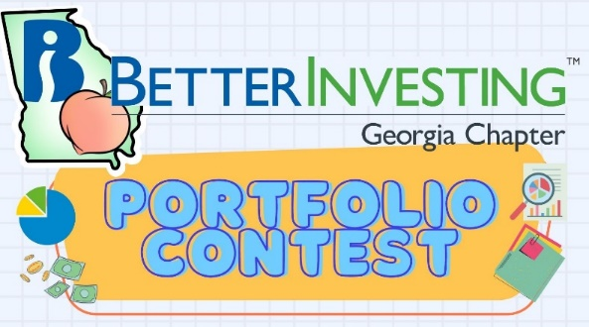

The 2024 Portfolio Contest is underway! The portfolios have been submitted and the contest has begun! We will provide updates each month during our Monthly Mentoring sessions, every 2nd Thursday of the month.
The contest will continue from now until December when the winning portfolio will be announced. The investments are imaginary, but the prizes are real!

Want to learn more? Check out all the details on our Webpage.

Contacts
Chapter Email: contact@georgia.betterinvesting.net
Chapter Webpage: www.betterinvesting.org/georgia
Follow Us On Facebook: www.facebook.com/betterinvestinggeorgiachapter
Join Us On Meetup: https://www.meetup.com/bigachapter

Share This Newsletter
Would you or someone you know benefit from receiving timely news about investing education programs?
Forward this newsletter!
And be sure to get all the great information we send out by signing up on our webpage HERE.

