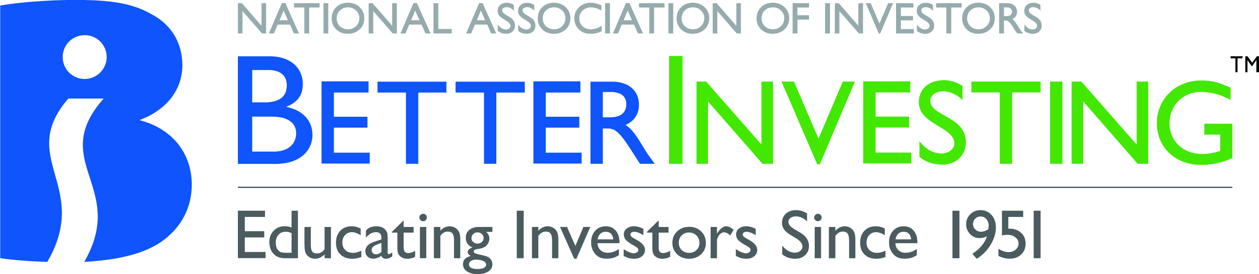 | Organization Code of Ethics
Human Resources | Procedure 5.0
 | Updated 2/2023

Contents

- Scope
- Purpose
- Certificate of Understanding and Compliance
- Policy
- Compliance
- Questions

- SCOPE

This policy applies to all officers, directors, employees including full-time, part-time and temporary, and contract staff, as well as members of the Editorial Advisory and Securities Review Committee (the “individuals”) of the National Association of Investors Corporation dba BetterInvesting (the “Organization”).

- PURPOSE
The Organization, wishing to foster the highest standards of investment education and dedicated to delivering the resources that will enable individuals to become Better Investors, establishes this Organization Code of Ethics (the “Code”).
- CERTIFICATE OF UNDERSTANDING AND COMPLIANCE

All individuals will be required to sign, annually, a certificate of understanding and compliance (see Code of Ethics Certificate of Understanding and Compliance) acknowledging and accepting the provisions of the Code.

- POLICY

At the Organization we expect all individuals to conduct business in an ethical and lawful manner, complying with all applicable laws in a manner that excludes considerations of personal advantage or gain.

The standards presented in the Code cannot cover every situation. The following is a summary of the Organization’s policy with respect to:

- Use of Inside Information. The Organization has a long-standing commitment to compliance with applicable Federal securities laws and regulations. The Organization publishes BetterInvesting Magazine. Individuals in the normal course of business may become aware, before publication, of a number of stocks, or other investments, that will be mentioned including Stocks to Study.

This information is privileged and confidential. Federal securities laws and the policies of the Organization provide that individuals have a duty not to (i) disclose the information to any family member or other person, (ii) buy, sell or recommend any securities on the basis of the information (whether for personal, investment club, or any other accounts), or (iii) permit any person to buy or sell any securities on the basis of the information. These restrictions apply until the information has been adequately disclosed to the public, which means that information must be publicly disclosed, and adequate time must have passed for the securities market to digest the information. A delay of three days is generally considered a sufficient period for routine information to be absorbed by the market.

- Gifts, Favors, Entertainment, and Payments. Individuals shall not offer, accept or solicit money, property, service or other items of more than $100.00 from any person or entity that does business, or desires to do business with the Organization. An individual may accept payment for travel expenses that are consistent with the Organization’s Business Expense Policy to attend or speak at an investor education event. (Refer to BetterInvesting, Purchasing Procedure and Authority Delegation as well as BetterInvesting Business Expense Policy).

- Organization-Owned Property. Individuals shall not use any Organization owned facility, building, equipment, material, or vehicle for their personal use or benefit, or for the personal use or benefit of any other individual. No individual shall have unauthorized possession of Organization property.

- Conflicts of Interest. Individuals are expected to dedicate their best efforts of advancing the Organization’s interests and to use objective and unbiased standards when making decisions that affect the entire NAIC Organization (BetterInvesting and ICLUBcentral). A conflict of interest occurs when an individual’s private interests interfere in any way, or even appear to interfere, with the interests of the Organization. All individuals are obligated to conduct the Organization’s business in an honest and ethical manner including the ethical handling of actual or apparent conflicts of interest between private and business relationships. Any individual shall make prompt and full disclosure in writing of any potential situation which may involve a conflict of interest and forward such disclosure to the Organization’s CEO, or Director of Shared Services. If any potential situation may involve the CEO, then this disclosure should be sent to the Chair of the Finance & Audit Committee.

- Confidential Information. The revelation or use of any confidential product information, data on decisions, plans, or any other information including financials and membership metrics which might be contrary to the interest of the Organization without prior authorization, is strictly prohibited. The misuse, unauthorized access to, or mishandling of confidential information, including personnel information, is strictly prohibited.

- Computer System Security and Control. The Organization utilizes various computer equipment and automated systems in the processing of data and the maintenance of member, historical, and other files. These computer resources are vital to the Organization and must be protected against accidental or intentional modification or destruction. All individuals are responsible for following established Organization policies and procedures, including any aspect of confidentiality, regarding computers and data assets. By signing this Code of Ethics, the individual hereby agrees to the entirety of the current version of the NAIC/BetterInvesting Technology Policy; originally approved June 2021, updated February 2023.
In general, the use of good judgment, based on high ethical principles, will be the guide to standards of acceptable conduct. If a situation arises where it is difficult to determine the proper course of action, the matter must be disclosed to the CEO, Director of Shared Services or the Chair of the Finance and Audit Committee.
- COMPLIANCE

Violations of the Code may subject the individual to discipline, including termination of employment, service, or contract. Any individual having knowledge of any violation of the Code must promptly report such violation to any of the following:

- Ken Zendel, CEO
Phone: (248) 654-3053, Email: kzendel@betterinvesting.org
- Cliff Trent, Director of Shared Services
Phone: (248) 654-3035, Email: clifft@betterinvesting.org

If any potential situation may involve the CEO, then this report should be sent to the Chair of the Finance & Audit Committee.

- QUESTIONS

For questions concerning any aspect of this policy contact the Director of Shared Services.

NAIC BetterInvesting reserves the right to modify or amend this policy at any time as it may deem necessary.

ORGANIZATION CODE OF ETHICS
CERTIFICATE OF UNDERSTANDING AND COMPLIANCE

All officers, directors, employees including full-time, part-time and temporary, and contract staff (the “individuals”) of the National Association of Investors Corporation dba BetterInvesting (the “Organization”) are required to complete and sign, annually, this Organization Code of Ethics (the “Code”) Certificate of Understanding and Compliance, and return the Certificate to the Director of Shared Services.
If you are not in compliance, or if there is some question or issue that you need to clarify before signing this certificate, contact the CEO, Director of Shared Services or the Chair of the Finance and Audit Committee.

Print Full Name

Relationship with Organization (check one)
Officer and/or Director
Employee -- Full-Time, Part-Time or Temporary
Contract staff (e.g. freelancer)
Editorial Advisory and Securities Review Committee member

I certify that I have received, read and understand the Organization Code of Ethics.

- I acknowledge and accept the provisions of the Code and understand that my present and continued relationship with the Organization requires that I comply with all provisions of the Code. Failure to comply with the Code may subject me to discipline, including termination of employment, service, or contract.

- I recognize that I have an obligation to report any violation of the Code, whether personally involved or aware of a possible violation by any other individual, promptly to the CEO, Director of Shared Services or the Chair of the Finance and Audit Committee.

Signature Date

