

Georgia Chapter March Bulletin

March Madness… for Your Portfolio 🏀📈

March is here, and just like the NCAA basketball tournament, the markets can bring their share of surprises, upsets, and breakout performers. Just as fans fill out their brackets, investors evaluate companies, compare fundamentals, and try to identify the strongest contenders.

The Georgia Chapter believes successful investing, like a winning tournament run, comes down to preparation, discipline, and learning from others along the way. This month’s mentoring session and model club meetings offer a great opportunity to sharpen your skills and stay engaged with the BetterInvesting community.

Let’s jump into what’s coming up this month!


Upcoming Events

Thursday, March 12th, 7:00 PM ET: Monthly Mentoring
Join us for our monthly mentoring session where members can ask questions, discuss stock ideas, and strengthen their investing knowledge together.
Register For Mentoring Here: REGISTER HERE

Saturday, March 14th, 12:00 PM ET: ACME Model Club Meeting
Curious how an investment club works? Join ACME to observe how members analyze companies and make decisions together.
Join The Meeting Here: https://global.gotomeeting.com/join/594493789

Saturday, March 15th, 12:00 PM ET: Central Georgia Model Investment Club (CGMIC) Meeting
Join CGMIC for a collaborative discussion of stock ideas and club operations. These meetings are open to the public and great for anyone interested in club investing.
Join The Meeting Here: https://global.gotomeeting.com/join/735717165
Keep Up With All The Latest Georgia Chapter Events Here

Monthly Mentoring Series
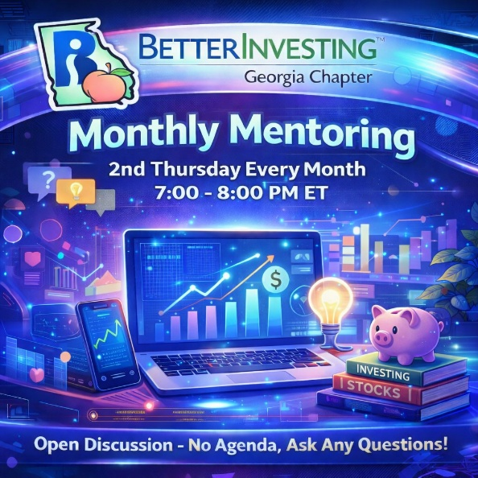
Monthly Mentoring continues with our dive into the First Cut Report. Follow along with your own SSG and First Cut Report as we discuss the process for completing an SSG and First Cut.
Join us every month on the 2nd Thursday at 7:00 PM ET for an in-depth look into different aspects of the SSG. Have questions? Get them answered here!
REGISTER HERE to be an SSG insider.
Did you miss a session? Check out our previous Mentoring recordings here: https://gotostage.com/channel/gachaptmentoring
Portfolio Contest
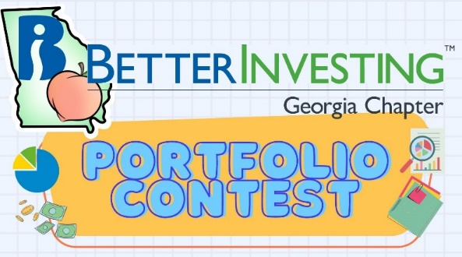

The 2026 Portfolio Contest is underway! Each month we review portfolio progress during our mentoring sessions and track how participants’ strategies are performing throughout the year.

It’s always interesting to see which companies pull ahead - and which ones create a few surprises along the way.

Follow along with us during mentoring each month to see how the portfolios evolve. The contest will continue from now until December when the winning portfolio will be announced. The investments are imaginary, but the prizes are real!

Want to learn more? Check out all the details on our Webpage.

Volunteer With The GA Chapter

🙌 Volunteer With Us
The Georgia Chapter continues to grow thanks to the dedication of our volunteers. If you’ve been thinking about getting more involved, we’d love to hear from you.
Volunteering with the chapter is a great way to support fellow investors, contribute to financial education across Georgia, and connect with the BetterInvesting community.
📩 Interested? Reach out to us at contact@georgia.betterinvesting.net

Support The Georgia Chapter

Support the BetterInvesting Georgia Chapter and help us empower investors of all levels!

We are a 100% volunteer-led 501(c)(3) organization dedicated to investor education throughout Georgia.

As tax season approaches, consider making a charitable contribution to the Georgia Chapter. Your donation is tax-deductible and helps us continue providing mentoring sessions, educational events, and resources to investors across the state.

Every contribution helps strengthen our investing community.

Contacts
Chapter Email: contact@georgia.betterinvesting.net
Chapter Webpage: www.betterinvesting.org/georgia
Follow Us On Facebook: www.facebook.com/betterinvestinggeorgiachapter
Join Us On Meetup: https://www.meetup.com/bigachapter

Share This Newsletter
Would you or someone you know benefit from receiving timely news about investing education programs?
Forward this bulletin!
And be sure to get all the great information we send out by signing up on our webpage HERE.



