

Georgia Chapter December Bulletin
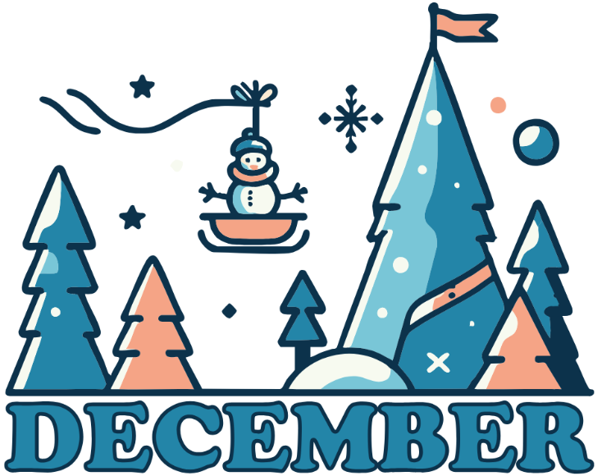

Wrapping Up a Great Year of Better Investing 🎁📈

December is here - and with it comes a time for reflection, celebration, and a little planning for the year ahead. As we close out 2025, we want to thank each of you for being an active part of the Georgia Chapter community. From mentoring sessions to model club meetings to the unforgettable Investor Education Fair, this has been a year full of learning and connection.

We’re finishing the year strong with a final round of club meetings - and then taking a short break to rest and recharge. We’ll be back in January with fresh insights, new mentoring content, and all the momentum to make 2026 another great year.


Upcoming Events

Saturday, December 13th, 12:00 PM ET: ACME Model Club
The ACME club meets on the 2nd Saturday of the month at noon. Wrap up the year with a final look at what’s moving the markets and how one of our model clubs works in real time. Everyone is welcome.
Join The Meeting Here: https://global.gotomeeting.com/join/594493789

Saturday, December 20th, 12:00 PM ET: Central Georgia Model Investment Club (CGMIC) Meeting
CGMIC meets monthly on the 3rd Saturday at noon. End the year with a live discussion of stock ideas and club operations. Public and beginner-friendly!
Join The Meeting Here: https://global.gotomeeting.com/join/735717165

Keep Up With All The Latest Georgia Chapter Events Here

Monthly Mentoring Series
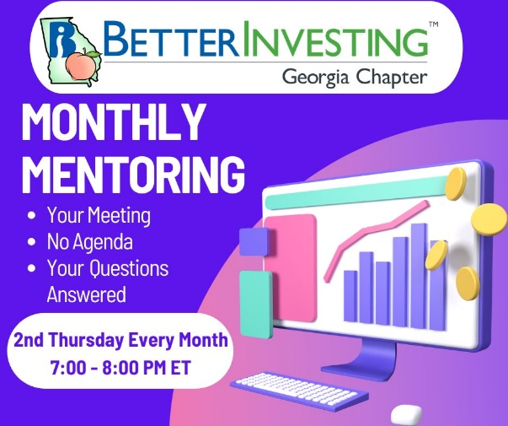
No December Session – Back January 8th!
There will be no Monthly Mentoring Session in December as we take a break for the holidays.
🎉 Thank you to everyone who participated this year—your engagement and enthusiasm made every session better. We’ll return Thursday, January 8th at 7:00 PM ET with new company studies and investing topics to kick off 2026.
Wishing you and your families a joyful, peaceful holiday season!
Did you miss a session? Check out our previous Mentoring recordings here: https://gotostage.com/channel/gachaptmentoring

Portfolio Contest
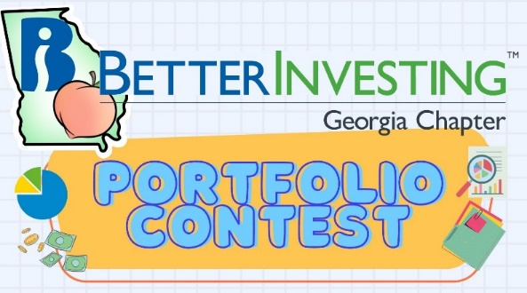
🏆 Portfolio Contest – Looking Ahead to 2026

The 2025 Portfolio Contest has officially wrapped, and we’ll be announcing the winner during our January mentoring session. Be sure to tune in as we reveal who topped the leaderboard and discuss strategies that stood out.

Want to join the fun in 2026?
🗓️ Submissions for the 2026 Portfolio Contest are due by December 31st!

It’s a great opportunity to put your stock-picking skills to the test, track your portfolio across the year, and see how your strategy stacks up.

Learn more and check out all the details on our Webpage.

Winter 2025 Newsletter
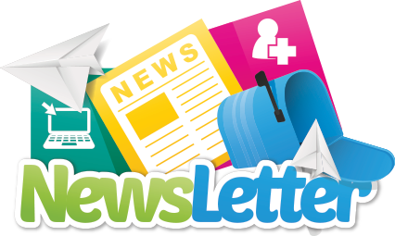

The Winter 2025 edition of the BetterInvesting Georgia Chapter Newsletter is here on our website and includes fresh updates, upcoming events, investing insights, and inspiration to help you make the most of this investing holiday season.

Check it out HERE and stay connected with your Georgia Chapter investing community.

Volunteer With The GA Chapter

🙌 Join the Georgia Chapter Board in 2026

We’re looking for enthusiastic volunteers to help guide our programs, events, and outreach in the new year. Whether you’re a longtime member or just getting involved, we welcome your ideas and energy.

Interested? Reach out to us at contact@georgia.betterinvesting.net

Support The Georgia Chapter

Support the BetterInvesting Georgia Chapter and help us empower investors of all levels!
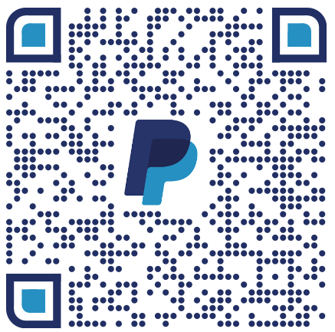
💙 Support the Georgia Chapter

As a volunteer-led 501(c)(3), we rely on donations to continue offering high-quality education, events, and mentoring programs.

This holiday season, consider making a contribution to help us bring BetterInvesting resources to more investors across Georgia in 2026.

🎁 Every gift makes a difference.



Contacts
Chapter Email: contact@georgia.betterinvesting.net
Chapter Webpage: www.betterinvesting.org/georgia
Follow Us On Facebook: www.facebook.com/betterinvestinggeorgiachapter
Join Us On Meetup: https://www.meetup.com/bigachapter
Share This Bulletin
Would you or someone you know benefit from receiving timely news about investing education programs?
Forward this bulletin!
And be sure to get all the great information we send out by signing up on our webpage HERE.


