better-investing

Georgia Chapter June Bulletin

Soaking Up the Sunshine and Smart Investing! ☀️

Summer is right around the corner, and with longer days and brighter skies, it’s a great time to shine some light on your investing goals. Whether you’re heading out on vacation or simply enjoying a slower pace, June offers a perfect opportunity to check in on your portfolio, explore new tools, and keep learning.

At the Georgia Chapter, we’re here to help you stay cool, stay curious, and stay connected with a community of investors who know that financial growth—just like a summer garden—requires consistent care and attention.

We’ve got plenty of updates, events, and inspiration to keep your investing journey moving forward. So grab an iced tea, find a shady spot, and dive into this month’s bulletin!

Happy Summer—and Happy Investing!

**Upcoming Events**

Thursday, June 12th, 7:00 PM ET: Monthly Mentoring

The Monthly Mentoring Sessions are held every 2nd Thursday of the month and are open to all Georgia Chapter Clubs and Members.

This is your opportunity to get your questions answered. No agenda, you control the discussion.

**Register For Mentoring Here:** [REGISTER HERE](https://register.gotowebinar.com/register/3296493531289169498)

CANCELLED - Saturday, June 14th, 12:00 PM ET: ACME Model Club

The ACME meeting is cancelled this month due to schedule conflicts with BINC. We hope everyone has a great time at the investor fair and joins us next month on our regularly scheduled 2nd Saturday.

Saturday, June 21st, 12:00 PM ET: Central Georgia Model Investment Club (CGMIC) Meeting

CGMIC meets monthly on the 3rd Saturday at noon. Meetings are free and open to the public.

**Join The Meeting Here**: <https://global.gotomeeting.com/join/735717165>

[Keep Up With All The Latest Georgia Chapter Events Here](https://www.betterinvesting.org/chapters/georgia/local-events)

**Monthly Mentoring Series**

](https://www.betterinvesting.org/chapters/georgia/local-events/club-and-individual-mentoring-jun)

Monthly Mentoring continues with our dive into the SSG and First Cut Report.

This month, our Director Clair will talk with us about his First Cut Report for United Rentals, Inc. (URI). United Rentals is an American equipment rental company. It owns the largest rental fleet in the world with approximately 4,700 classes of equipment totaling about $19.3 billion in original equipment cost as of 2022.

You can create your own SSG and First Cut for URI and follow along as Clair discusses his thought process for completing an SSG and First Cut.

Join us every month on the 2nd Thursday at 7:00 PM ET for an in-depth look into different aspects of the SSG. Have questions? Get them answered here!

[REGISTER HERE](https://register.gotowebinar.com/register/3296493531289169498) to be an SSG insider.

Did you miss a session? Check out our previous Mentoring recordings here: <https://gotostage.com/channel/gachaptmentoring>

**Portfolio Contest**

[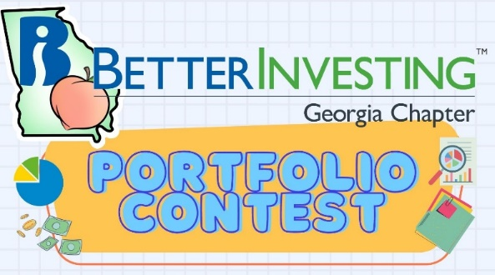](https://www.betterinvesting.org/chapters/georgia/news-articles)

The 2025 Portfolio Contest is in full swing, the portfolios have been submitted, and the contest in underway! Be sure to follow along with our portfolio hopefuls this year. Contest progress is updated every month during our Monthly Mentoring Series.

The contest will continue from now until December when the winning portfolio will be announced. The investments are imaginary, but the prizes are real!

Want to learn more? Check out all the details on our [Webpage](https://www.betterinvesting.org/chapters/georgia/news-articles).

**Spring 2025 Newsletter**

[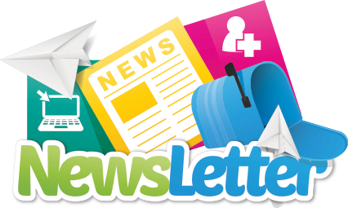](https://www.betterinvesting.org/getmedia/cc51e464-89e8-4781-8488-72c5a564c3bb/2025-newsletter-first-qtr-revised.pdf)

The Spring 2025 edition of the BetterInvesting Georgia Chapter Newsletter is here on our website and includes fresh updates, upcoming events, investing insights, and inspiration to help you make the most of this season of growth.

Check it out [HERE](https://www.betterinvesting.org/getmedia/cc51e464-89e8-4781-8488-72c5a564c3bb/2025-newsletter-first-qtr-revised.pdf) and stay connected with your Georgia Chapter investing community. And you can find issues of previous newsletters on our [Webpage](https://www.betterinvesting.org/chapters/georgia/news-articles).

**Investors Education Fair**

](https://www.betterinvesting.org/chapters/georgia/local-events/annual-investor-education-fair-aug)

Mark your calendars, the Georgia Chapter Investors Education Fair is back for its 11th year on Saturday, August 23rd! Join us in-person for outstanding classes taught by some of the best in the BetterInvesting community. Stay tuned for all the updates and learn more on out [webpage.](https://www.betterinvesting.org/chapters/georgia/local-events/annual-investor-education-fair-aug)

**Support The Georgia Chapter**

Support the **BetterInvesting Georgia Chapter** and help us empower investors of all levels!

](https://www.paypal.com/biz/profile/georgiachapterbi)

As a volunteer-led 501(c)(3) organization, we provide education, resources, and community support to the **BetterInvesting investment club network**, helping individuals build wealth through smart, long-term investing.

Your donation allows us to offer workshops, mentoring, and valuable tools to new and experienced investors alike. Every contribution makes a difference—**invest in financial literacy today! 💙📈**

](https://www.paypal.com/biz/profile/georgiachapterbi)

**Contacts**

Chapter Email: [contact@georgia.betterinvesting.net](mailto:contact@georgia.betterinvesting.net)

Chapter Webpage: [www.betterinvesting.org/georgia](http://www.betterinvesting.org/georgia)

Follow Us On Facebook: [www.facebook.com/betterinvestinggeorgiachapter](http://www.facebook.com/betterinvestinggeorgiachapter)

Join Us On Meetup: [https://www.meetup.com/bigachapter](https://na01.safelinks.protection.outlook.com/?url=https%3A%2F%2Flists.betterinvesting.org%2Flink.php%3FM%3D1786145%26N%3D26166%26L%3D15619%26F%3DH&data=05%7C01%7C%7C837e11ba7e2f4ff7906d08db94117bbf%7C84df9e7fe9f640afb435aaaaaaaaaaaa%7C1%7C0%7C638266575040350710%7CUnknown%7CTWFpbGZsb3d8eyJWIjoiMC4wLjAwMDAiLCJQIjoiV2luMzIiLCJBTiI6Ik1haWwiLCJXVCI6Mn0%3D%7C3000%7C%7C%7C&sdata=w6mbsV55ShlnBNxaepfTqs2i4DX5TaMVUAxX%2Bfkbk9k%3D&reserved=0)

**Share This Bulletin**

Would you or someone you know benefit from receiving timely news about investing education programs?

Forward this bulletin!

And be sure to get all the great information we send out by signing up on our webpage [HERE](https://www.betterinvesting.org/chapters/georgia#frmChapterSubscribe).

