

Georgia Chapter February Bulletin

Investing with Purpose and Heart 💙📈

As we step into February—a month centered on connection and community—we’re reenergizing our commitment to smarter investing, financial education, and supporting one another as BetterInvesting members. Whether you're celebrating the successes of January or just getting into your stride for the year, the Georgia Chapter is here to help keep you on track.

We’ve got a full month ahead, including mentoring focused on tax season, club meetings, and new chances to engage and learn.


In Memory of Charles Lemon and Cynthia McCrary
We are saddened to share that two of our respected Georgia Chapter volunteers, Charles Lemon and Cynthia McCrary, have passed away.

Both Charles and Cynthia were valuable, enthusiastic chapter volunteers who dedicated themselves to education, mentorship, and community outreach. Their commitment to helping others learn and grow as investors left a lasting impact on our clubs and the broader Georgia Chapter community.

We, the Georgia Chapter Board, are saddened by their passings, but we will appreciate the time we shared together and remember our friends with great fondness. Their legacy of service and generosity will continue to inspire us.


Upcoming Events

Thursday, February 12th, 7:00 PM ET : Monthly Mentoring
Join us with a timely focus on tax season and as always, open Q&A, stock discussion, and community support for investors at all levels.
Register For Mentoring Here: REGISTER HERE

Saturday, February 14th, 12:00 PM ET: ACME Model Club
Spend your Valentine’s with the ACME club and share your love of smart investing! Open to the public and always beginner friendly.
Join The Meeting Here: https://global.gotomeeting.com/join/594493789

Saturday, February 21st, 12:00 PM ET: Central Georgia Model Investment Club (CGMIC) Meeting
Join the CGMIC for collaborative stock analysis and club leadership discussions.
Join The Meeting Here: https://global.gotomeeting.com/join/735717165

Keep Up With All The Latest Georgia Chapter Events Here

Monthly Mentoring Series
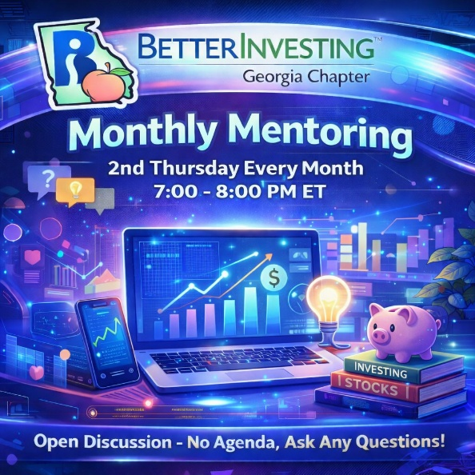

Tax Talk with Jim Vandersall 💾💬

Tax season is here, and that can bring a lot of pressure for investment clubs—especially for treasurers. But you’re not alone. The Georgia Chapter is your support system, and we’re here to help guide you through it.

Join us Thursday, February 12th at 7:00 PM ET for a special session led by Jim Vandersall, who will break down common tax-season issues and host an open Q&A. Whether it’s K-1s, or general club tax guidance—bring your questions and let us help!
REGISTER HERE to be an SSG insider.

Did you miss a session? Check out our previous Mentoring recordings here: https://gotostage.com/channel/gachaptmentoring

Portfolio Contest
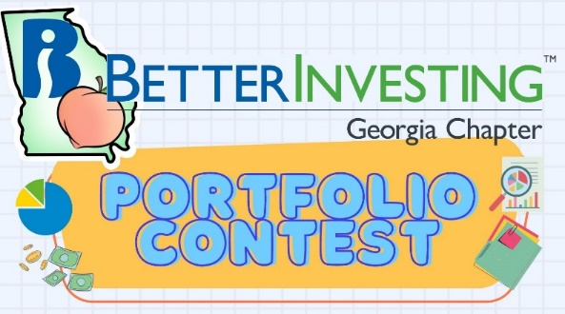

🏆 Portfolio Contest – 2026 is Underway!

The 2026 Portfolio Contest is off to a strong start! Each month, we’ll review and track portfolio performance live during the monthly mentoring session. It’s a great way to follow along, compare strategies, and get inspired by fellow investors’ stock picks.

If you’re participating—best of luck! And if you’re curious, come join us to see how the portfolios evolve throughout the year.
Learn more and check out all the details on our Webpage.

Winter Newsletter


📰 Winter 2025 Newsletter – Still Available

Don’t forget to check out the Winter 2025 Georgia Chapter Newsletter—it’s packed with education insights, club highlights, and updates on what’s coming next.

Check it out HERE and stay connected with your Georgia Chapter investing community.

Volunteer With The GA Chapter

🙌 Volunteer With Us

If you're ready to take the next step in your investing journey, consider volunteering with the Georgia Chapter Board! It’s a rewarding way to give back, grow your leadership skills, and connect with a passionate group of like-minded investors.

Interested? Reach out to us at contact@georgia.betterinvesting.net

Support The Georgia Chapter
💙 Support the Georgia Chapter

We’re a 100% volunteer-led 501(c)(3) chapter, and we rely on generous supporters like you to fund our programs. Your donation helps us continue offering events, mentoring, and resources to investors at every stage.



📬 Consider making a tax-deductible gift this January to fuel our mission in 2026.Support the BetterInvesting Georgia Chapter and help us empower investors of all levels!



Contacts
Chapter Email: contact@georgia.betterinvesting.net
Chapter Webpage: www.betterinvesting.org/georgia
Follow Us On Facebook: www.facebook.com/betterinvestinggeorgiachapter
Join Us On Meetup: https://www.meetup.com/bigachapter

Share This Bulletin
Would you or someone you know benefit from receiving timely news about investing education programs?
Forward this bulletin!
And be sure to get all the great information we send out by signing up on our webpage HERE.


