better-investing

Georgia Chapter July Bulletin

Celebrating Financial Independence!

As we gather to celebrate the Fourth of July, it’s a powerful reminder that independence—financial or otherwise—is built on vision, discipline, and thoughtful decision-making. Much like building a strong nation, building a strong portfolio is about consistency, strategy, and long-term focus.

The BetterInvesting Georgia Chapter is here to support that focus with practical education, reliable tools, and a vibrant community of investors. Whether you’re new to investing or looking to sharpen your strategy, July is a great time to reconnect and recharge your portfolio.

Keep reading for updates on our Annual Meeting, mentoring events, and exciting opportunities on the horizon—including the return of our Investors Education Fair in August!

Here’s to freedom, growth, and Better Investing!

**Upcoming Events**

Thursday, July 10th, 7:00 PM ET: Monthly Mentoring

The Monthly Mentoring Sessions are held every 2nd Thursday of the month.

Get your questions answered in real time—no agenda, just great discussion! Open to all Georgia Chapter Clubs and Members.

**Register For Mentoring Here:** [REGISTER HERE](https://register.gotowebinar.com/register/3296493531289169498)

Saturday, July 12th, 12:00 PM ET: ACME Model Club

The ACME club meets on the 2nd Saturday of the month at noon. Curious about investment clubs? Join us to observe and learn—everyone is welcome!

**Join The Meeting Here:** <https://global.gotomeeting.com/join/594493789>

Saturday, July 19th, 12:00 PM ET: Central Georgia Model Investment Club (CGMIC) Meeting

CGMIC meets monthly on the 3rd Saturday at noon. Meetings are free and open to the public.

**Join The Meeting Here**: <https://global.gotomeeting.com/join/735717165>

Saturday, July 26th, 2:00 PM ET: Georgia Chapter Annual Meeting

Fayette County Public Library, 1821 Heritage Park Way Fayetteville, GA 30214

**Register For The Meeting Here**: [REGISTER HERE](https://register.gotowebinar.com/register/1041109308623733077)

[Keep Up With All The Latest Georgia Chapter Events Here](https://www.betterinvesting.org/chapters/georgia/local-events)

**Annual Meeting**

Join us Saturday, July 26th at 2:00 PM ET at the Fayette County Public Library or online. This is your opportunity to connect directly with our board, hear about chapter milestones, and contribute to our future direction. Please join us online or in person at the Fayette County Public Library, 1821 Heritage Pkwy, Fayetteville, GA 30214.

[REGISTER HERE](https://register.gotowebinar.com/register/1041109308623733077) or learn more about this event on our [webpage](https://www.betterinvesting.org/chapters/georgia/local-events/annual-meeting-july).

**Monthly Mentoring Series**

](https://register.gotowebinar.com/register/3296493531289169498)

Monthly Mentoring continues with our dive into the SSG and First Cut Report. You can create your own SSG and First Cut and follow along as Director Cliff discusses his thought process for completing an SSG and First Cut.

Join us every month on the 2nd Thursday at 7:00 PM ET for an in-depth look into different aspects of the SSG. Have questions? Get them answered here!

[REGISTER HERE](https://register.gotowebinar.com/register/3296493531289169498) to be an SSG insider.

Did you miss a session? Check out our previous Mentoring recordings here: <https://gotostage.com/channel/gachaptmentoring>

**Portfolio Contest**

[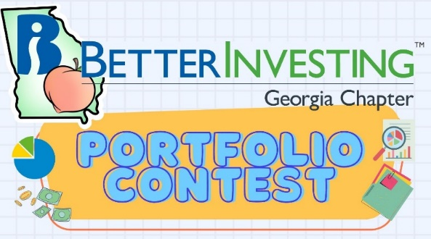](https://www.betterinvesting.org/chapters/georgia/news-articles)

We’re deep into the summer stretch of the 2025 Portfolio Contest—and the competition is heating up! Portfolio performance updates are shared during each Monthly Mentoring session.

The contest continues through December, where the winning portfolio (and bragging rights) will be announced.  
🏆 The investments are imaginary, but the prizes are real!

Want to learn more? Check out all the details on our [Webpage](https://www.betterinvesting.org/chapters/georgia/news-articles).

**Spring 2025 Newsletter**

[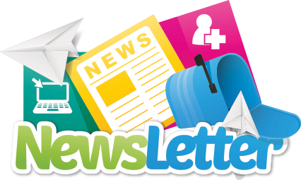](https://www.betterinvesting.org/getmedia/cc51e464-89e8-4781-8488-72c5a564c3bb/2025-newsletter-first-qtr-revised.pdf)

The Spring 2025 edition of the BetterInvesting Georgia Chapter Newsletter is here on our website and includes fresh updates, upcoming events, investing insights, and inspiration to help you make the most of this season of growth.

Check it out [HERE](https://www.betterinvesting.org/getmedia/cc51e464-89e8-4781-8488-72c5a564c3bb/2025-newsletter-first-qtr-revised.pdf) and stay connected with your Georgia Chapter investing community. And you can find issues of previous newsletters on our [Webpage](https://www.betterinvesting.org/chapters/georgia/news-articles).

**Investors Education Fair**

Registration Now Open!!

[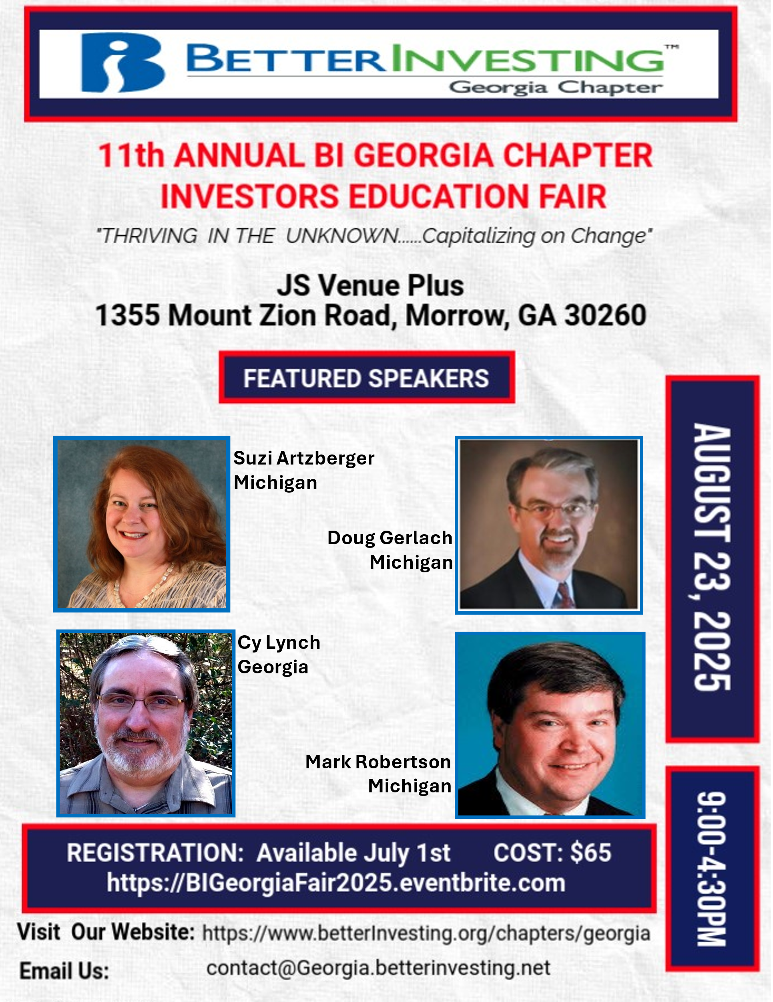](https://www.betterinvesting.org/chapters/georgia/local-events/annual-investor-education-fair-aug)

Our 11th Annual Investors Education Fair is just around the corner! Join us Saturday, August 23rd for a day packed with practical classes taught by some of BetterInvesting’s most experienced educators.

Registration is now open! Don’t miss out on a great day of education, community, and BetterInvesting!

](https://www.eventbrite.com/e/betterinvesting-georgia-chapter-11th-annual-investors-fair-tickets-1378581908599?aff=oddtdtcreator)

**Support The Georgia Chapter**

Support the **BetterInvesting Georgia Chapter** and help us empower investors of all levels!

](https://www.paypal.com/biz/profile/georgiachapterbi)

As a volunteer-led 501(c)(3) organization, we provide education, resources, and community support to the **BetterInvesting investment club network**, helping individuals build wealth through smart, long-term investing.

Your donation allows us to offer workshops, mentoring, and valuable tools to new and experienced investors alike. Every contribution makes a difference—**invest in financial literacy today! 💙📈**

](https://www.paypal.com/biz/profile/georgiachapterbi)

**Contacts**

Chapter Email: [contact@georgia.betterinvesting.net](mailto:contact@georgia.betterinvesting.net)

Chapter Webpage: [www.betterinvesting.org/georgia](http://www.betterinvesting.org/georgia)

Follow Us On Facebook: [www.facebook.com/betterinvestinggeorgiachapter](http://www.facebook.com/betterinvestinggeorgiachapter)

Join Us On Meetup: [https://www.meetup.com/bigachapter](https://na01.safelinks.protection.outlook.com/?url=https%3A%2F%2Flists.betterinvesting.org%2Flink.php%3FM%3D1786145%26N%3D26166%26L%3D15619%26F%3DH&data=05%7C01%7C%7C837e11ba7e2f4ff7906d08db94117bbf%7C84df9e7fe9f640afb435aaaaaaaaaaaa%7C1%7C0%7C638266575040350710%7CUnknown%7CTWFpbGZsb3d8eyJWIjoiMC4wLjAwMDAiLCJQIjoiV2luMzIiLCJBTiI6Ik1haWwiLCJXVCI6Mn0%3D%7C3000%7C%7C%7C&sdata=w6mbsV55ShlnBNxaepfTqs2i4DX5TaMVUAxX%2Bfkbk9k%3D&reserved=0)

**Share This Bulletin**

Would you or someone you know benefit from receiving timely news about investing education programs?

Forward this bulletin!

And be sure to get all the great information we send out by signing up on our webpage [HERE](https://www.betterinvesting.org/chapters/georgia#frmChapterSubscribe).

