

Georgia Chapter August Bulletin

Back to School, BetterInvesting Style! 📚📈

August means back-to-school season, and students aren’t the only ones heading back to the classroom! Lifelong learning is an important part of becoming a better investor, and this month the Georgia Chapter has the perfect opportunity to continue your investing education.

You can go back to school with BetterInvesting at our 12th Annual Georgia Chapter Investor Education Fair on August 22nd. With a full day of virtual classes, experienced instructors, and investing education, consider it your opportunity to sharpen those pencils—or perhaps your SSG skills—and learn something new!

We also have our regular Monthly Mentoring and CGMIC meetings this month, so there are plenty of opportunities to learn, connect, and become a better investor.


Upcoming Events

Thursday, August 13th, 7:00 PM ET: Monthly Mentoring
Join us for our monthly mentoring session featuring discussion of the Stock Selection Guide, First Cut Report, Portfolio Contest, and plenty of time for your investing questions.
Register For Mentoring Here: REGISTER HERE

Saturday, August 15th , 12:00 PM ET: Central Georgia Model Investment Club (CGMIC) Meeting
Join fellow investors for collaborative stock analysis, investment discussion, and club learning. Visitors are always welcome!
Join The Meeting Here: https://global.gotomeeting.com/join/735717165
Saturday, August 22nd , 9:00 AM ET – 4:00 PM ET: 12th Annual Investor Education Fair
Our biggest educational event of the year is almost here! Registration is open for this full-day virtual event featuring 12 investing classes and four nationally recognized BetterInvesting educators.
Register Today & Join Us Online! REGISTER HERE

Keep Up With All The Latest Georgia Chapter Events Here

Investors Education Fair

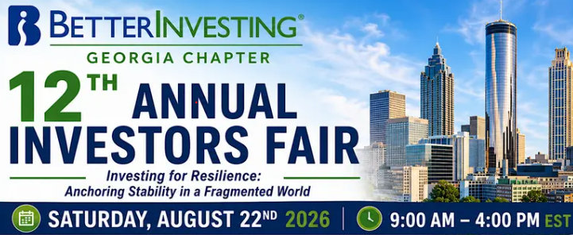
🎓 12th Annual Georgia Chapter Investor Education Fair

Registration is Open – Join Us August 22nd!

It’s almost here! Join us Saturday, August 22nd from 9:00 AM – 4:00 PM ET for the 12th Annual Georgia Chapter Investor Education Fair, a full-day virtual investing event designed to educate, inspire, and connect investors of every experience level.

This year’s theme, “Investing for Resilience: Anchoring Stability in a Fragmented World,” features 12 educational sessions led by nationally recognized BetterInvesting educators Cy Lynch, Christi Powell, Kevin Gillogly, and Bakul Lalla.

From improving your Stock Selection Guide skills and portfolio management to retirement planning, estate planning, and using artificial intelligence for investment research, we have assembled a full day of classes with something for just about every investor.

And best of all, you can attend from anywhere! Grab your coffee, fire up your computer, and spend the day learning with the Georgia Chapter and the greater BetterInvesting community.

Registration is open for this virtual online event!



Reserve your seat through our Georgia Chapter Webpage

Or Register Directly HERE!

We look forward to seeing you online on August 22nd!

Monthly Mentoring Series

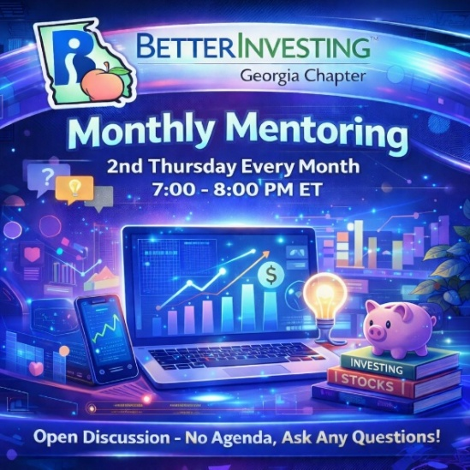

Monthly Mentoring continues in August with another opportunity to strengthen your understanding of the Stock Selection Guide (SSG) and First Cut Report.

Each month we explore different aspects of the BetterInvesting methodology while maintaining an open format for questions and discussion. Whether you’re working through your first SSG, analyzing a new company, or simply have an investing question you’d like to discuss, bring it with you!

📅 Join us every month on the 2nd Thursday at 7:00 PM ET. Have questions? Get answers here!
REGISTER HERE to be an SSG insider.

Did you miss a session? Check out our previous Mentoring recordings here:
https://www.gotostage.com/channel/gachaptmentoring

Portfolio Contest
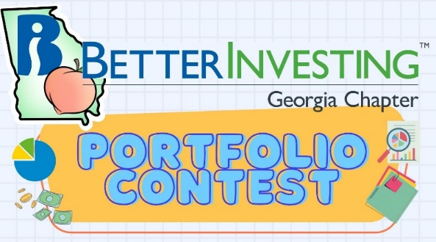
🏆 Portfolio Contest – Progress Update

The 2026 Portfolio Contest rolls into August, and with more than half the year behind us, the competition is getting interesting!

Follow along during our Monthly Mentoring sessions as we review the latest standings and see how our contestants’ stock selections and strategies are performing.

📊 Find the latest contest results here: Standings & Portfolio Performance

Join us during Mentoring to see how the portfolios are progressing and learn from fellow participants. Want to learn more? Check out all the details on our Webpage.

There’s still plenty of investing year left, so keep following along to see which portfolios ultimately rise to the top!

Summer 2026 Newsletter
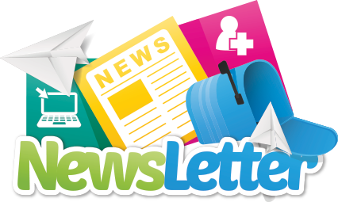

📰 Have you read the Summer 2026 Georgia Chapter Newsletter yet?

Our latest edition is available now on the Georgia Chapter Webpage and is filled with chapter news, educational content, club updates, and information about what’s happening throughout the BetterInvesting community.

If you haven’t had a chance to read it yet, stop by our Webpage and check it out!
Volunteer With The GA Chapter


🙌 Volunteer With the Georgia Chapter

The Georgia Chapter is a volunteer organization, and everything we accomplish—from Monthly Mentoring to the Investor Education Fair—is made possible by people who generously contribute their time and talents.

We’re always looking for new volunteers and future Georgia Chapter directors. Whether your interests include education, mentoring, communications, technology, event planning, or community outreach, there are plenty of ways to get involved.

Come join our team and help us continue supporting BetterInvesting clubs and individual investors throughout Georgia!

📩 Interested? Reach out to us at: contact@georgia.betterinvesting.net

Stay Connected
Chapter Email: contact@georgia.betterinvesting.net
Chapter Webpage: www.betterinvesting.org/georgia
Follow Us On Facebook: www.facebook.com/betterinvestinggeorgiachapter
Join Us On Meetup: https://www.meetup.com/bigachapter

Share This Bulletin
📢 Know someone who would benefit from BetterInvesting's educational programs and resources?

Forward this bulletin and invite them to connect with us. The Georgia Chapter is here to help investors learn, connect, and become better investors—so help us spread the word!

Get all the great information we send out by signing up on our webpage HERE.

