

Georgia Chapter October Bulletin


Falling Leaves, Strong Portfolios, and a Dash of Spooky Season 🎃📈

October is here—and with it comes cooler weather, falling leaves, and of course, spooky season! Whether you're prepping costumes, stocking up on candy, or trying to avoid getting tricked into a bad investment, now’s the perfect time to treat yourself to some fresh financial insights.

This month, your Georgia Chapter has plenty in store: from model club meetings and mentoring to the final leg of our portfolio contest. So carve out some time between football games and trick-or-treaters to reconnect with your investing goals and keep the momentum going into year-end.


Upcoming Events

Thursday, October 9th, 7:00 PM ET: Monthly Mentoring
The Monthly Mentoring Sessions are held every 2nd Thursday of the month.
Get your questions answered in real time—no agenda, just great discussion! Open to all Georgia Chapter Clubs and Members.
Register For Mentoring Here: REGISTER HERE

Saturday, October 11th, 12:00 PM ET: ACME Model Club
The ACME club meets on the 2nd Saturday of the month at noon. Curious about investment clubs? Join us to observe and learn—everyone is welcome!
Join The Meeting Here: https://global.gotomeeting.com/join/594493789

Saturday, October 18th, 12:00 PM ET: Central Georgia Model Investment Club (CGMIC) Meeting
CGMIC meets monthly on the 3rd Saturday at noon. Meetings are free and open to the public.
Join The Meeting Here: https://global.gotomeeting.com/join/735717165

Keep Up With All The Latest Georgia Chapter Events Here

Monthly Mentoring Series
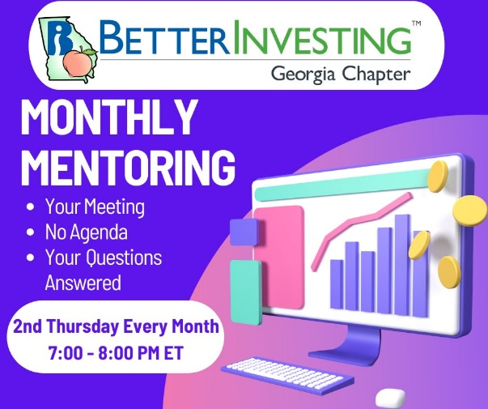
Flying into Fundamentals: ISSC with Howard Johnson ✈️📊
Join us Thursday, October 9th at 7:00 PM ET for this month’s Mentoring session, featuring a presentation from Howard Johnson on Innovative Solutions and Support, Inc. (ISSC).
Howard will walk us through his First Cut Report and SSG, showcasing his approach to analyzing this aviation technology company known for flight display systems and avionics upgrades. This is a great opportunity to see real-world application of BetterInvesting tools, ask questions, and gain insight into how others structure their research.
Whether you're a seasoned investor or still getting comfortable with the SSG, this session will offer plenty of actionable takeaways. Create your own SSG and First Cut for ISSC and follow along!
Join us every month on the 2nd Thursday at 7:00 PM ET for an in-depth look into different aspects of the SSG. Have questions? Get them answered here!
REGISTER HERE to be an SSG insider.
Did you miss a session? Check out our previous Mentoring recordings here: https://gotostage.com/channel/gachaptmentoring

Portfolio Contest
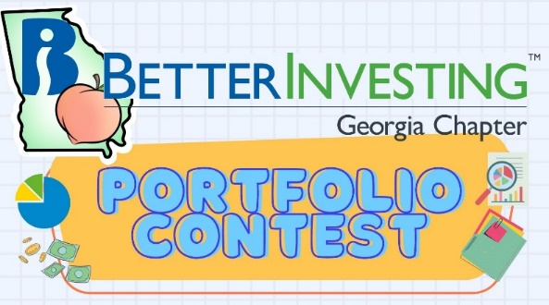
🏆 Portfolio Contest – Final Quarter

We’re entering the home stretch of the 2025 Portfolio Contest! With just a couple of months to go, it's getting competitive at the top of the leaderboard.

Monthly progress is shared during our mentoring sessions, and the winner will be revealed in December. Imaginary dollars, real bragging rights.

Thinking about next year’s contest? Now’s the time to start building your dream portfolio for 2026.

Want to learn more? Check out all the details on our Webpage.

Volunteer With The GA Board

Join the Georgia Chapter Board

We’re looking for a few great volunteers to join the Georgia Chapter Board. If you’re passionate about investing, education, and building community—this is your opportunity to make an impact.

As a board member, you’ll help plan events, support local clubs, and make a real impact on our BetterInvesting community across the state. Volunteers also receive benefits such as discounted annual membership fees, discounted registration for BINC, discounted ICLUBcentral products, and more!

No prior board experience required—just a willingness to contribute and learn.

Interested? Reach out to us at contact@georgia.betterinvesting.net
Support The Georgia Chapter

Support the BetterInvesting Georgia Chapter and help us empower investors of all levels!

As a volunteer-led 501(c)(3) organization, we provide education, resources, and community support to the BetterInvesting investment club network, helping individuals build wealth through smart, long-term investing.

Your donation allows us to offer workshops, mentoring, and valuable tools to new and experienced investors alike. Every contribution makes a difference—invest in financial literacy today! 💙📈



Contacts
Chapter Email: contact@georgia.betterinvesting.net
Chapter Webpage: www.betterinvesting.org/georgia
Follow Us On Facebook: www.facebook.com/betterinvestinggeorgiachapter
Join Us On Meetup: https://www.meetup.com/bigachapter

Share This Bulletin
Would you or someone you know benefit from receiving timely news about investing education programs?
Forward this bulletin!
And be sure to get all the great information we send out by signing up on our webpage HERE.


