

Georgia Chapter April Bulletin

Spring Into Smarter Investing 🌸📈

April is here, bringing longer days, fresh energy, and a great opportunity to refocus on your financial goals. Just like spring cleaning around the house, it’s the perfect time to revisit your portfolio, evaluate your strategy, and make thoughtful adjustments for the months ahead.

With tax season wrapping up and markets continuing to evolve, staying engaged and informed is more important than ever. The Georgia Chapter is here to support you with mentoring, education, and a strong investing community.

Let’s make April a productive month for your portfolio!


Upcoming Events

Thursday, April 9th, 7:00 PM ET: Monthly Mentoring
Join us for our monthly mentoring session where members can ask questions, discuss stock ideas, and strengthen their investing knowledge together.
Register For Mentoring Here: REGISTER HERE

Saturday, April 11th, 12:00 PM ET: ACME Model Club Meeting
Curious how an investment club works? Join ACME to observe how members analyze companies and make decisions together.
Join The Meeting Here: https://global.gotomeeting.com/join/594493789

Saturday, April 18th, 12:00 PM ET: Central Georgia Model Investment Club (CGMIC) Meeting
Join CGMIC for a collaborative discussion of stock ideas and club operations. These meetings are open to the public and great for anyone interested in club investing.
Join The Meeting Here: https://global.gotomeeting.com/join/735717165

Keep Up With All The Latest Georgia Chapter Events Here

Monthly Mentoring Series
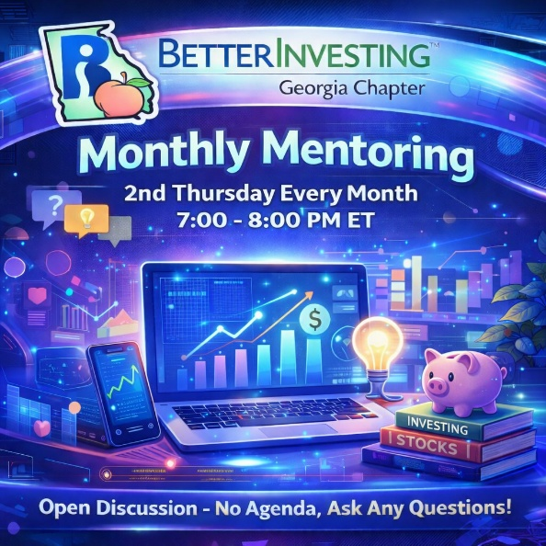
Monthly Mentoring continues with our ongoing focus on strengthening your understanding of the Stock Selection Guide (SSG) and the First Cut Report. Each session provides a practical walkthrough of key concepts, helping you build confidence in evaluating companies and making informed investment decisions.
We encourage you to bring your own SSGs, First Cuts, and questions to the session. Whether you're just getting started or looking to refine your approach, these discussions are designed to be interactive and valuable for investors at all levels.
Join us every month on the 2nd Thursday at 7:00 PM ET for an in-depth look into different aspects of the SSG. Have questions? Get them answered here!
REGISTER HERE to be an SSG insider.
Did you miss a session? Check out our previous Mentoring recordings here: https://gotostage.com/channel/gachaptmentoring
Portfolio Contest
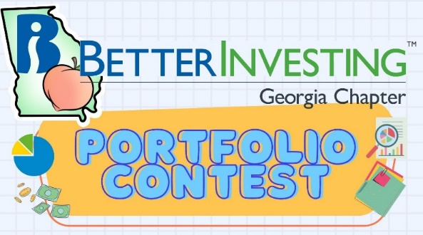

🏆 Portfolio Contest – 2026 Progress Update

The 2026 Portfolio Contest is underway, and the competition is starting to take shape. Each month, we review portfolio performance during our mentoring sessions—offering a great opportunity to see different strategies in action and learn from fellow investors.

Want to follow along in real time?
📊 Track the latest Standings and Portfolio Performance Here.

Follow along with us during mentoring each month to see how the portfolios evolve. The contest will continue from now until December when the winning portfolio will be announced. The investments are imaginary, but the prizes are real!

Want to learn more? Check out all the details on our Webpage.

Volunteer With The GA Chapter

🙌 Volunteer With Us
The Georgia Chapter continues to grow thanks to the dedication of our volunteers. If you’ve been thinking about getting more involved, we’d love to hear from you.
Volunteering with the chapter is a great way to support fellow investors, contribute to financial education across Georgia, and connect with the BetterInvesting community.
📩 Interested? Reach out to us at contact@georgia.betterinvesting.net

Contacts
Chapter Email: contact@georgia.betterinvesting.net
Chapter Webpage: www.betterinvesting.org/georgia
Follow Us On Facebook: www.facebook.com/betterinvestinggeorgiachapter
Join Us On Meetup: https://www.meetup.com/bigachapter

Share This Newsletter
Would you or someone you know benefit from receiving timely news about investing education programs?
Forward this bulletin!
And be sure to get all the great information we send out by signing up on our webpage HERE.



