

Georgia Chapter June Bulletin
\

Summer Learning, Smarter Investing ☀️📈

June has arrived, bringing longer days, warmer temperatures, and plenty of opportunities to continue growing as investors. As we move into the summer months, it's a great time to stay engaged, refine your investing skills, and take advantage of the educational resources available through the Georgia Chapter.

Whether you're following the Portfolio Contest, attending Monthly Mentoring, or preparing for our annual Investor Education Fair, there are plenty of ways to stay connected and continue learning this summer.


Upcoming Events

Thursday, June 11th, 7:00 PM ET: Monthly Mentoring
Join us for another engaging mentoring session where members can ask questions, discuss stock ideas, and strengthen their investing knowledge together.
Register For Mentoring Here: REGISTER HERE

Saturday, June 20th, 12:00 PM ET: Central Georgia Model Investment Club (CGMIC) Meeting
Join CGMIC for collaborative stock analysis and investment discussion. Open to all investors.
Join The Meeting Here: https://global.gotomeeting.com/join/735717165

Keep Up With All The Latest Georgia Chapter Events Here
Monthly Mentoring Series
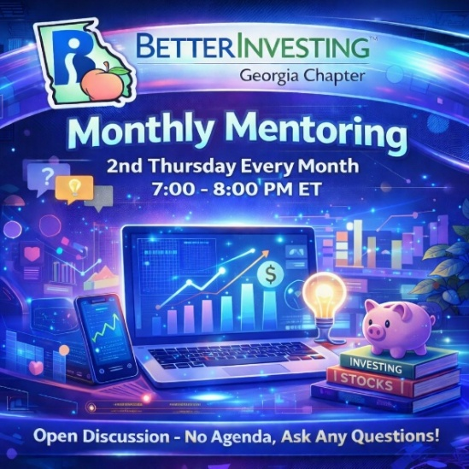

Monthly Mentoring continues with another practical look at the First Cut Report and Stock Selection Guide (SSG).

This month, Claire Redmond will walk us through his First Cut Report and SSG on Karat Packaging (KRT). Follow along as Claire shares his approach to evaluating a company using BetterInvesting tools and discusses the factors that stood out during his analysis.

We encourage members to create their own SSG and First Cut for KRT ahead of the session and compare notes during the discussion.

📅 Join us every month on the 2nd Thursday at 7:00 PM ET. Have questions? Bring them with you!
REGISTER HERE to be an SSG insider.

Did you miss a session? Check out our previous Mentoring recordings here:
https://www.gotostage.com/channel/gachaptmentoring

Portfolio Contest
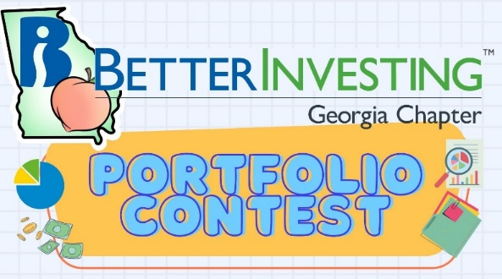
🏆 Portfolio Contest – Progress Update

The 2026 Portfolio Contest continues to provide an exciting opportunity to compare investing strategies and follow portfolio performance throughout the year.

Each month, we review the latest standings during our mentoring session and discuss the companies driving performance.

📊 Find the latest contest results here: Standings & Portfolio Performance

Join us during Mentoring to see how the portfolios are progressing and learn from fellow participants. Want to learn more? Check out all the details on our Webpage.

Spring 2026 Newsletter


📰 Spring 2026 Newsletter – Available Now!

If you haven't already, be sure to check out the Spring 2026 Georgia Chapter Newsletter, available now on our Webpage.

The newsletter includes chapter updates, educational articles, club highlights, upcoming events, and other information designed to help you become a more informed investor.
📄 Visit our Webpage to read the latest edition.

Investors Education Fair

🎓 12th Annual Georgia Chapter Investor Education Fair

📅 Save the Date – Saturday, August 22nd!

The Georgia Chapter's 12th Annual Investor Education Fair is right around the corner.

This virtual event will feature a full day of investing education, presentations, discussion, and learning opportunities designed for investors of all experience levels.

Mark your calendar now and stay tuned for additional information, speaker announcements, and registration details in the coming weeks.

Volunteer With The GA Chapter


🙌 Volunteer With the Georgia Chapter

The Georgia Chapter's success is made possible by our dedicated volunteers.

If you've been looking for a way to give back to the BetterInvesting community, we'd love to hear from you. Whether your interests are education, event planning, outreach, technology, or mentoring, there are opportunities to get involved.

Volunteering is a rewarding way to support investor education while connecting with fellow BetterInvesting members.

📩 Interested? Reach out to us at: contact@georgia.betterinvesting.net

Stay Connected
Chapter Email: contact@georgia.betterinvesting.net
Chapter Webpage: www.betterinvesting.org/georgia
Follow Us On Facebook: www.facebook.com/betterinvestinggeorgiachapter
Join Us On Meetup: https://www.meetup.com/bigachapter

Share This Bulletin
📢 Know someone who would benefit from BetterInvesting's educational programs and resources?

Forward this bulletin and invite them to connect with the Georgia Chapter community. The more investors we can reach, the stronger our investing community becomes.

Get all the great information we send out by signing up on our webpage HERE.



