**How to Take Over the Family Finances….*Alone***

**Essential Documents**

**and Instructions**

***Presented by the Puget Sound Chapter Better Investing***

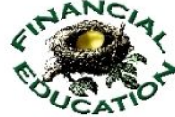



How to take over the Family Finances….Alone

How to take over the Family Finances….Alone

How to take over the Family Finances….Alone

How to take over the Family Finances….Alone

How to take over the Family Finances….Alone

How to take over the Family Finances….Alone

How to take over the Family Finances….Alone