

Georgia Chapter January Bulletin

New Year, New Goals, Smarter Investing 🎯📈

Happy New Year from the Georgia Chapter! With 2026 officially underway, it’s the perfect time to revisit our financial goals and recommit to long-term investing. Whether you're a seasoned club member or a solo investor just getting started, we’re here to help you sharpen your skills and grow your portfolio all year long.

Let’s start the year strong with great events, a full slate of model club meetings, and the return of our popular monthly mentoring series. See below for everything coming up this month—and don’t forget to invite a friend or fellow investor to join in!


Upcoming Events

Thursday, January 8th, 7:00 PM ET : Monthly Mentoring
We’re back! Join us as we kick off the new year with open Q&A, stock discussion, and community support for investors at all levels.
Register For Mentoring Here: REGISTER HERE

Saturday, January 10th, 12:00 PM ET: ACME Model Club
Join Georgia’s flagship model club for live analysis, club operations, and discussion. Open to the public and always beginner friendly.
Join The Meeting Here: https://global.gotomeeting.com/join/594493789

Saturday, January 17th, 12:00 PM ET: Central Georgia Model Investment Club (CGMIC) Meeting
Participate in stock analysis and discussion with fellow Central Georgia investors.
Join The Meeting Here: https://global.gotomeeting.com/join/735717165

Keep Up With All The Latest Georgia Chapter Events Here

Monthly Mentoring Series
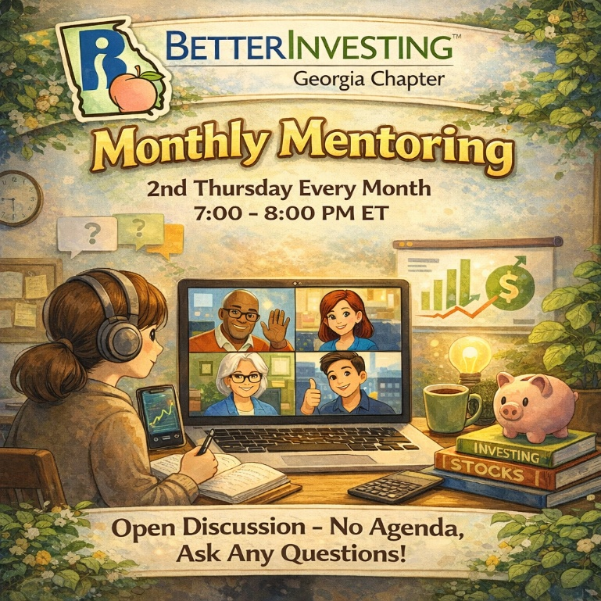
Monthly Mentoring is Back!
After a well-deserved December break, our Monthly Mentoring series returns Thursday, January 8th at 7:00 PM ET! We will be discussing the SSG and First Cut report on Constellation Brands (STZ).
Constellation Brands, Inc. (STZ) is an American producer and marketer of beer, wine, and spirits. A Fortune 500 company, Constellation is the largest beer import company in the US, measured by sales, and has the third-largest market share of all major beer suppliers.
Whether you're looking for guidance on a specific aspect of the SSG, exploring a potential buy/sell decision, or simply want to learn from others—our mentoring team is here to support you.
No prep required. Just show up, ask questions, and grow your confidence as an investor. And join us every month on the 2nd Thursday at 7:00 PM ET for an in-depth look into the SSG.
REGISTER HERE to be an SSG insider.
Did you miss a session? Check out our previous Mentoring recordings here: https://gotostage.com/channel/gachaptmentoring

Portfolio Contest
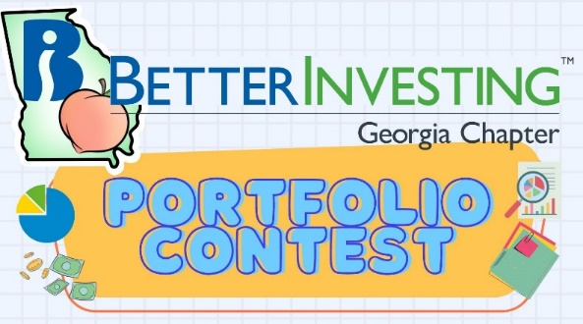

The 2025 Portfolio Contest has officially wrapped, and we’ll be announcing the winner during our January mentoring session. Be sure to tune in as we reveal who topped the leaderboard and discuss strategies that stood out. Thank you to all who participated and well done!

Did you miss out on the portfolio contest deadline, but still want to join in on the fun? Be sure to follow along with our portfolio hopefuls this year. Contest progress is updated every month during our Monthly Mentoring Series.

It’s a great opportunity to put your stock-picking skills to the test, track your portfolio across the year, and see how your strategy stacks up.

Learn more and check out all the details on our Webpage.

Winter Newsletter

📰 Winter 2025 Newsletter – In Case You Missed It

Our latest seasonal newsletter is packed with updates, education highlights, and volunteer spotlights. Be sure to check it out on the chapter webpage if you missed it over the holidays.

Check it out HERE and stay connected with your Georgia Chapter investing community.

Volunteer With The GA Chapter

🙌 New Year, New Opportunities to Volunteer

Looking for a way to give back in 2026? We’re inviting new volunteers to join the Georgia Chapter Board! Help us shape events, support clubs, and expand financial literacy across the state. No experience required—just energy, passion, and a love for learning.

Interested? Reach out to us at contact@georgia.betterinvesting.net

Support The Georgia Chapter
💙 Support the Georgia Chapter

We’re a 100% volunteer-led 501(c)(3) chapter, and we rely on generous supporters like you to fund our programs. Your donation helps us continue offering events, mentoring, and resources to investors at every stage.



📬 Consider making a tax-deductible gift this January to fuel our mission in 2026.Support the BetterInvesting Georgia Chapter and help us empower investors of all levels!



Contacts
Chapter Email: contact@georgia.betterinvesting.net
Chapter Webpage: www.betterinvesting.org/georgia
Follow Us On Facebook: www.facebook.com/betterinvestinggeorgiachapter
Join Us On Meetup: https://www.meetup.com/bigachapter
Share This Bulletin
Would you or someone you know benefit from receiving timely news about investing education programs?
Forward this bulletin!
And be sure to get all the great information we send out by signing up on our webpage HERE.


