

Georgia Chapter July Bulletin


Independence Through Investing 

July is a time to celebrate independence, and there's no better opportunity to reflect on another kind of freedom—financial independence. While achieving long-term financial success doesn't happen overnight, every thoughtful investment, every company you study, and every lesson you learn moves you one step closer to your goals.

As we enjoy the summer months, the Georgia Chapter continues to provide opportunities to learn, connect, and grow together. We hope you'll join us for mentoring, follow the Portfolio Contest, and register for our biggest educational event of the year—the 12th Annual Georgia Chapter Investor Education Fair.

Upcoming Events

Thursday, July 9th, 7:00 PM ET: Monthly Mentoring
Continue building your investing knowledge through another engaging mentoring session featuring an SSG, First Cut Report, and open discussion.
Register For Mentoring Here: REGISTER HERE

Saturday, July 18th , 12:00 PM ET: Central Georgia Model Investment Club (CGMIC) Meeting
Join fellow investors for collaborative stock analysis, investment discussion, and club learning. Visitors are always welcome!
Join The Meeting Here: https://global.gotomeeting.com/join/735717165

Keep Up With All The Latest Georgia Chapter Events Here

Investors Education Fair

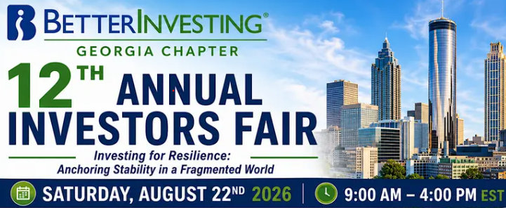

🎓 Registration is Now Open!

Join us on Saturday, August 22, 2026, from 9:00 AM – 4:00 PM ET for the 12th Annual Georgia Chapter Investor Education Fair, a full-day virtual investing event designed to educate, inspire, and connect investors of every experience level.

This year's theme, "Investing for Resilience: Anchoring Stability in a Fragmented World," features 12 educational sessions presented by nationally recognized BetterInvesting educators Cy Lynch, Christi Powell, Kevin Gillogly, and Bakul Lalla.

Whether you're looking to strengthen your Stock Selection Guide skills, improve your portfolio management process, learn retirement and estate planning strategies, or discover how artificial intelligence can enhance your stock research, this year's Investor Education Fair has something for every investor.

Registration is open for this virtual online event!



Reserve your seat through our Georgia Chapter Webpage

Or Register Directly HERE!

We look forward to spending the day with you online for an outstanding event filled with education, inspiration, and BetterInvesting fellowship.

Monthly Mentoring Series
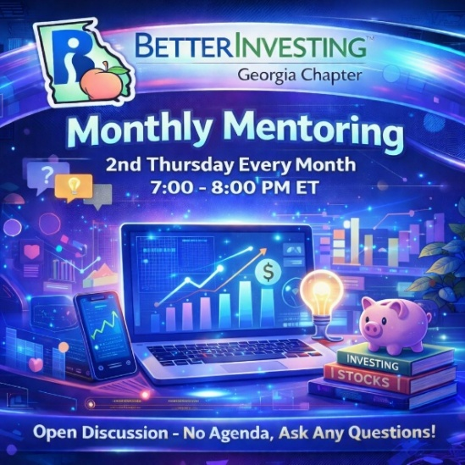

Monthly Mentoring continues with another deep dive into the Stock Selection Guide (SSG) and First Cut Report.

Each month we explore different aspects of BetterInvesting methodology while providing an open forum for questions, discussion, and shared learning. Whether you're completing your first SSG or refining your skills, these sessions are designed to help investors of every experience level.

📅 Join us every month on the 2nd Thursday at 7:00 PM ET. Have questions? Bring them with you!
REGISTER HERE to be an SSG insider.

Did you miss a session? Check out our previous Mentoring recordings here:
https://www.gotostage.com/channel/gachaptmentoring

Portfolio Contest
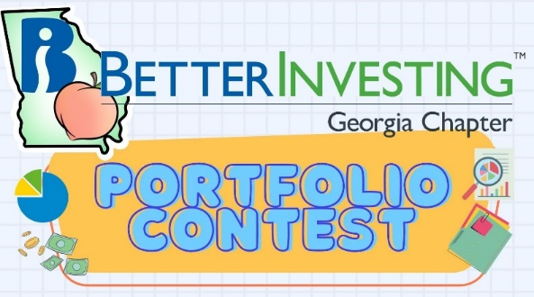
🏆 Portfolio Contest – Progress Update

The 2026 Portfolio Contest continues to gain momentum as we move through the summer. Follow along each month during our mentoring sessions as we review portfolio performance, discuss investment strategies, and see which companies are leading the way.

📊 Find the latest contest results here: Standings & Portfolio Performance

Join us during Mentoring to see how the portfolios are progressing and learn from fellow participants. Want to learn more? Check out all the details on our Webpage.

Summer 2026 Newsletter


📰 The Summer 2026 Georgia Chapter Newsletter is now available on our webpage!

Inside you'll find chapter news, educational articles, club highlights, upcoming events, and additional investing resources to help you become a more informed investor.

We encourage everyone to take a few minutes to read the latest edition and stay connected with everything happening across the Georgia Chapter.

📄 Visit our Webpage to read the latest edition.

Volunteer With The GA Chapter


🙌 Volunteer With the Georgia Chapter

Everything we accomplish is possible because of the dedication and enthusiasm of our volunteers.

If you've ever considered becoming more involved with the Georgia Chapter, we'd love to have you join us. Whether your interests include mentoring, education, event planning, communications, technology, or outreach, there's a place for you on our team.

Volunteering is one of the best ways to give back to the BetterInvesting community while helping fellow investors continue their financial education.

📩 Interested? Reach out to us at: contact@georgia.betterinvesting.net

Stay Connected
Chapter Email: contact@georgia.betterinvesting.net
Chapter Webpage: www.betterinvesting.org/georgia
Follow Us On Facebook: www.facebook.com/betterinvestinggeorgiachapter
Join Us On Meetup: https://www.meetup.com/bigachapter

Share This Bulletin
📢 Know someone who would benefit from BetterInvesting's educational programs and resources?

Forward this bulletin and invite them to connect with the Georgia Chapter community. The more investors we can reach, the stronger our investing community becomes.

Get all the great information we send out by signing up on our webpage HERE.



