Georgia Chapter October Bulletin
Upcoming Events

Thursday, October 12th, 7:00 PM ET: Monthly Mentoring
The Monthly Mentoring Sessions are held every 2nd Thursday of the month and are open to all Georgia Chapter Clubs and Members. This is your opportunity to get your questions answered. No agenda, you control the discussion.
Join The Meeting Here: https://global.gotomeeting.com/join/723544445

Saturday, October 14th, 12:00 PM ET: ACME Model Investment Club
The ACME club meets on the 2nd Saturday of the month at noon. All are welcome to come and learn about investing with us.
Join The Meeting Here: https://global.gotomeeting.com/join/594493789

Saturday, October 21st, 12:00 PM ET: Central Georgia Model Investment Club (CGMIC) Meeting
CGMIC meets monthly on the 3rd Saturday at noon. Meetings are free and open to the public.

Join The Meeting Here: https://global.gotomeeting.com/join/735717165

Keep Up With All The Latest Georgia Chapter Events Here

October Monthly Mentoring Session
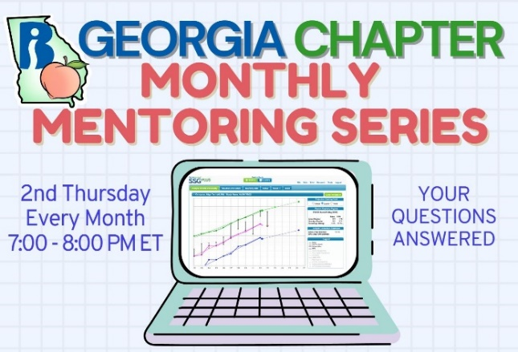
Club Meetings: is this real life, is this just fantasy? For our October Mentoring Session we will discuss club meeting platforms. You don’t have to meet face-to-face; many clubs meet online too!
The mentoring sessions are an open forum for you to ask questions on any topic.
Join us every 2nd Thursday at 7:00 PM ET, join the meeting HERE.

Portfolio Contest 2023
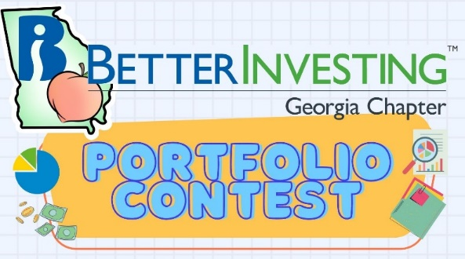
The Georgia Chapter Portfolio Contest is underway. The portfolios have been submitted and the contest is in its final quarter. We will provide updates each month during our Monthly Mentoring sessions every 2nd Thursday of the month.
The contest continues until December when the winning portfolio will be announced. The investments are imaginary, but the prizes are real!
Want to learn more? Check out all the details on our Webpage.
Did you miss out on the portfolio contest this year, but want to participate in the contest next year? Start thinking now about what stocks you would like to put in your dream portfolio and join us for the portfolio contest 2024!
Good luck and Better Investing!

Contacts
Chapter Email: contact@georgia.betterinvesting.net
Chapter Webpage: www.betterinvesting.org/georgia
Follow Us On Facebook: www.facebook.com/betterinvestinggeorgiachapter
Join Us On Meetup: https://www.meetup.com/bigachapter

Share This Newsletter
Would you or someone you know benefit from receiving timely news about investing education programs?
Forward this newsletter!
And be sure to get all the great information we send out by signing up on our webpage HERE.

