

Georgia Chapter September Bulletin
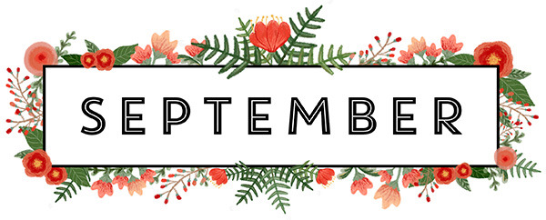
Fall Into Better Investing

September is here, bringing cooler days, the beginning of fall, and a new season of opportunities to learn and grow as investors. As summer winds down, it’s a great time to take another look at your portfolio, revisit your investing goals, and finish the year strong.

We’re also coming off a fantastic August for the Georgia Chapter! Our 12th Annual Investor Education Fair brought investors together from across the country for a full day of education and learning. Thank you to everyone who helped make the event such a success!

There’s plenty more ahead this fall, so grab that pumpkin-spiced coffee and let’s get started!

Upcoming Events

Thursday, September 10th, 7:00 PM ET: Monthly Mentoring
Join us for our monthly mentoring session featuring discussion of the Stock Selection Guide, First Cut Report, Portfolio Contest, and plenty of time for your investing questions.
Register For Mentoring Here: REGISTER HERE

Saturday, September 19th , 12:00 PM ET: Central Georgia Model Investment Club (CGMIC) Meeting
Join fellow investors for collaborative stock analysis, investment discussion, and club learning. Visitors are always welcome!
Join The Meeting Here: https://global.gotomeeting.com/join/735717165#s
Keep Up With All The Latest Georgia Chapter Events Here
Investors Education Fair

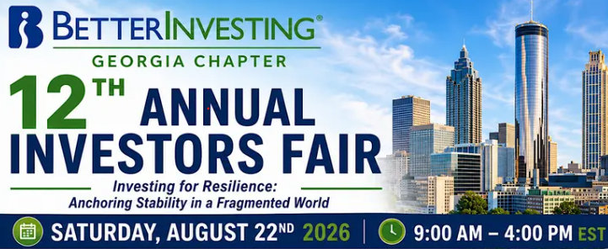

🎓 12th Annual Georgia Chapter Investor Education Fair – That’s a Wrap!

What a day! The 12th Annual Georgia Chapter Investor Education Fair is officially in the books, and we want to extend a huge THANK YOU to everyone who helped make this year’s event such a success.



Thank you to all of our Georgia Chapter volunteers who spent countless hours planning and preparing for the Fair, and to our outstanding presenters who shared their time, knowledge, and experience through a fantastic lineup of classes and educational sessions.

Most importantly, thank you to everyone who attended! We welcomed investors from all across the country, with 84 attendees joining us for a full day of investing education and BetterInvesting fellowship. We hope you enjoyed the day, learned something new, and left with a few new ideas to put to work in your own investing journey.
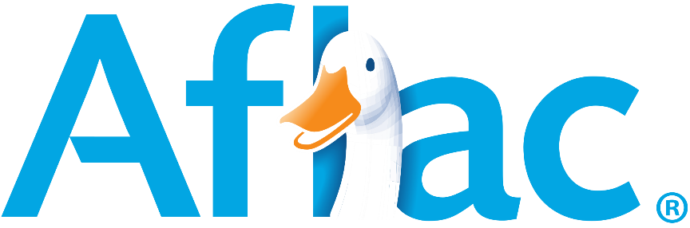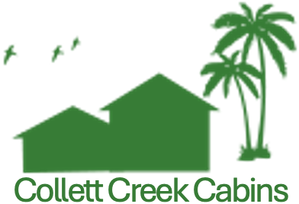

A special thank you also goes to our generous sponsors, Aflac and Collett Creek Cabins, for their support of this year’s event.



And we’re already looking ahead! Mark your calendars for Saturday, August 28, 2027, when the Georgia Chapter Investor Education Fair returns for another great year.
We can’t wait to do it all again!

Monthly Mentoring Series
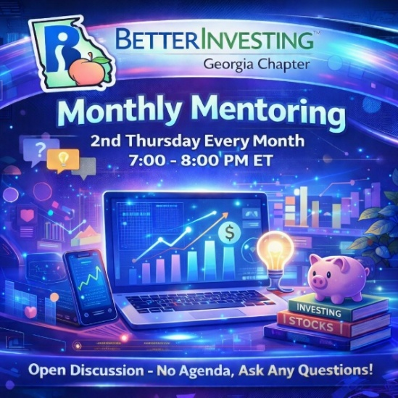

Monthly Mentoring continues with our dive into the Stock Selection Guide (SSG) and First Cut Report.

This month, Georgia Chapter Director Kyra will walk us through her SSG and First Cut Report on Costco (COST).
You can create your own SSG and First Cut for Costco ahead of time and follow along as Kyra discusses her analysis, assumptions, and process for evaluating the company.

Each month we explore different aspects of the BetterInvesting methodology while maintaining an open format for questions and discussion. Whether you’re working through your first SSG, analyzing a new company, or simply have an investing question you’d like to discuss, bring it with you!

📅 Join us every month on the 2nd Thursday at 7:00 PM ET. Have questions? Get answers here!
REGISTER HERE to be an SSG insider.

Did you miss a session? Check out our previous Mentoring recordings here:
https://www.gotostage.com/channel/gachaptmentoring

Portfolio Contest
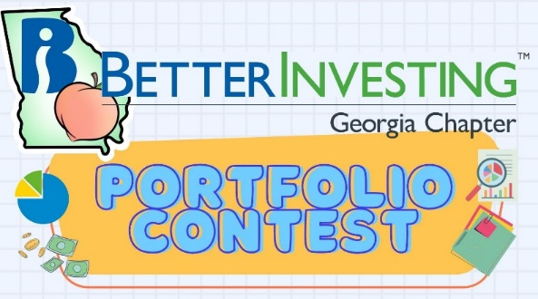
🏆 Portfolio Contest – Progress Update

The 2026 Portfolio Contest continues, and with fall approaching, we’re entering the home stretch!
Each month during Monthly Mentoring, we check in on the latest standings and follow how our contestants’ stock selections and strategies are performing. There’s still plenty of time for the leaderboard to change before the year is over.

📊 Find the latest contest results here: Standings & Portfolio Performance

Join us during Mentoring to see how the portfolios are progressing and learn from fellow participants. Want to learn more? Check out all the details on our Webpage.

Follow along with us each month and see which portfolio ultimately comes out on top!

Summer 2026 Newsletter


There’s still time to catch up on the Summer 2026 Georgia Chapter Newsletter, available now on our chapter webpage.

The newsletter is another great way to stay connected with the Georgia Chapter and includes investing education, chapter news, club updates, and information from around the BetterInvesting community.
📄 Visit our webpage and check out the latest edition!

Volunteer With The GA Chapter


🙌 Volunteer With the Georgia Chapter

The success of this year’s Investor Education Fair was another great reminder of just how important our Georgia Chapter volunteers are. Our programs, mentoring sessions, events, and outreach simply wouldn’t happen without volunteers willing to contribute their time and talents.

We’re always looking for enthusiastic members who would like to get more involved, including those interested in joining the Georgia Chapter Board. Whether your interests include education, mentoring, communications, technology, event planning, or community outreach, there’s a place for you.

Come join our team and help us continue supporting BetterInvesting clubs and individual investors throughout Georgia!

📩 Interested? Reach out to us at: contact@georgia.betterinvesting.net

Stay Connected
Chapter Email: contact@georgia.betterinvesting.net
Chapter Webpage: www.betterinvesting.org/georgia
Follow Us On Facebook: www.facebook.com/betterinvestinggeorgiachapter
Join Us On Meetup: https://www.meetup.com/bigachapter

Share This Bulletin
📢 Know someone interested in becoming a better investor?

Forward this bulletin and invite them to connect with us. The Georgia Chapter is here to help investors learn, connect, and become better investors—so help us spread the word!

Get all the great information we send out by signing up on our webpage HERE.

